PASSIVE LEVEL 2.

>>>The answers to these exercises are on the second page. <<<

A) Choose the correct form. Make sure you use the correct tense (tijd).

1. The car [is/ was jumped on] yesterday

2. The kitten [was fed / is being fed] right now

3. The dog [was walked / has been walked]

4. The building [had been/has been] renovated before it was sold.

5. The letter [was being/has being] written when she asked for it.

B). Fill in the correct form. Make sure you use the correct tense.

6. The dog ........................................................(washed) yesterday (~~by the man~~).

7. The cow ........................................................(milk) already, you don’t need to do it.

8. Next year, I .....................................................(fly) to Africa!

9. I ................................................... (zou gekozen kunnen worden) to play in this film!

10. Coffee ...................................(wordt gedronken) by people all over the world (feit).

C) Translate these sentences. Make sure you use the correct tense.

11. De fles werd gisteren gevuld.

12. De hond is gevoerd.

13. De airco wordt nu gemaakt.

14. De film wordt al getoond (shown) in deze bioscoop sinds 2013 (het is nu 2015).

15. The boterham werd gemaakt en toen kwam zij binnen.

D). Describe what happens/is happening/has happened with a passive sentence.

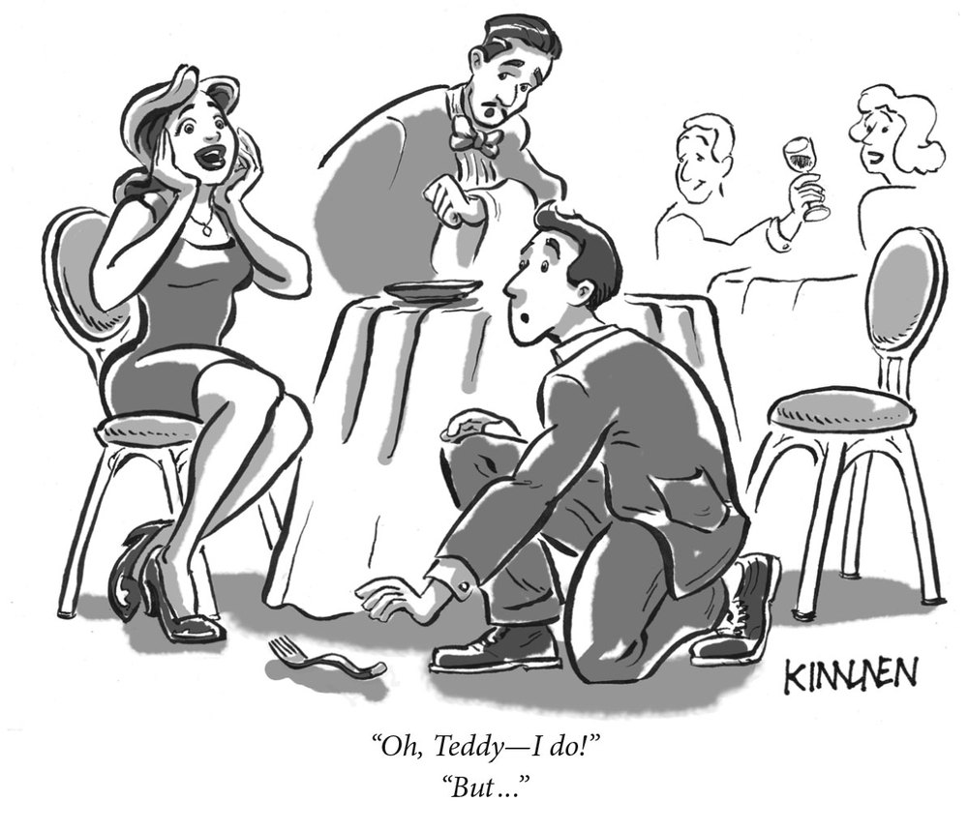

**ANSWERS**

A) Choose the correct form. Make sure you use the correct tense (tijd).

1. The car **was jumped** **on** yesterday (yesterday = use past simple)

2. The kitten **is being fed** right now (right now = use present continuous)

3. The dog **has been walked** ( past, but unclear when = present perfect)

4. The building **had been** renovated before it was sold (2 gebeurtenissen in het verleden, 1 vóór de ander: renoveren vóór het verkopen = past perfect)

5. The letter **was being** written when she asked for it. (iets langer bezig in het verleden, iets anders onderbreekt de actie = past continuous)

B). Fill in the correct form. Make sure you use the correct tense.

6. The dog **was washed** yesterday (~~by the man~~). (past simple)

7. The cow **has been milked** already, you don’t need to do it. (present perfect)

8. Next year, **I will/shall be flown** to Africa! (next year = future)

9. I **could be chosen** to play in this film! (zou kunnen = could)

10. Coffee **is drunk** by people all over the world (feit = present simple).

C) Translate these sentences. Make sure you use the correct tense.

11. The bottle was filled yesterday. (yesterday; past simple)

12. The dog has been fed. (verleden tijd, niet duidelijk wanneer: present perfect)

13. The airco is being fixed on right now. (present continuous: nu bezig)

14. The film has (already) been shown in this cinema since 2013. (verleden tijd, verleden begonnen en nu nog steeds bezig: present perfect)

15. The sandwich was being made when she came in. (past continuous)

D. Describe what is happening/has happened with a passive sentence.

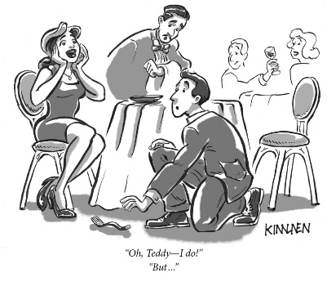**Some options**:

* The woman was/is/has been/is being/was being proposed to
* The fork was/is/has been dropped.
* The wine is/was/is being drunk
* The wine was being drunk when the man proposed to the woman.
* The wine was being drunk when the proposal was made.
* The mistake is/was/has been made.
* The chair is/was sat on.
* The menu was brought.
* The fork should not have been dropped.
* Longest passive sentence:   
  The fork had been dropped on the floor and when said fork was being picked up, the thought that she was being proposed to was thought.